# Department of Computing

## **Name : Mahum Samar**

## **CMS ID : 290647**

**CS220: Database Systems**

## **Class: BSCS 9B**

# **Lab Task**

Given the following database schema:

Student (snum: integer, sname: char(30), major: char(25), level: char(2))

Faculty (fid: integer, fname: char(30), deptid: integer)

Class (cname: char(40), meets_at: char(20), room: char(10), fid: integer | fid REFS Faculty.fid)

Enrolled (snum: integer, cname: char(40) | snum REFS student.snum, cname REFS class.name)

# Write SQL expressions for each of the following queries and execute them:

## Create a database for these four relations. You need to define the primary keys and foreign keys in your statement. After creating the database, evolve it as follows.

### Query:

CREATE SCHEMA School;

CREATE TABLE School.Student(

snum integer PRIMARY KEY,

sname char(30),

major char(30),

level char(2));

CREATE TABLE School.Faculty(

fid integer PRIMARY KEY,

fname char(30),

deptid integer);

CREATE TABLE School.Class(

cname char(40) PRIMARY KEY,

meets_at char(20),

room char(10),

fid integer,

FOREIGN KEY (fid) REFERENCES Faculty(fid)

);

CREATE TABLE School.Enrolled(

snum integer,

cname char(40),

FOREIGN KEY (snum) REFERENCES Student(snum),

FOREIGN KEY (cname) REFERENCES Class(cname)

);

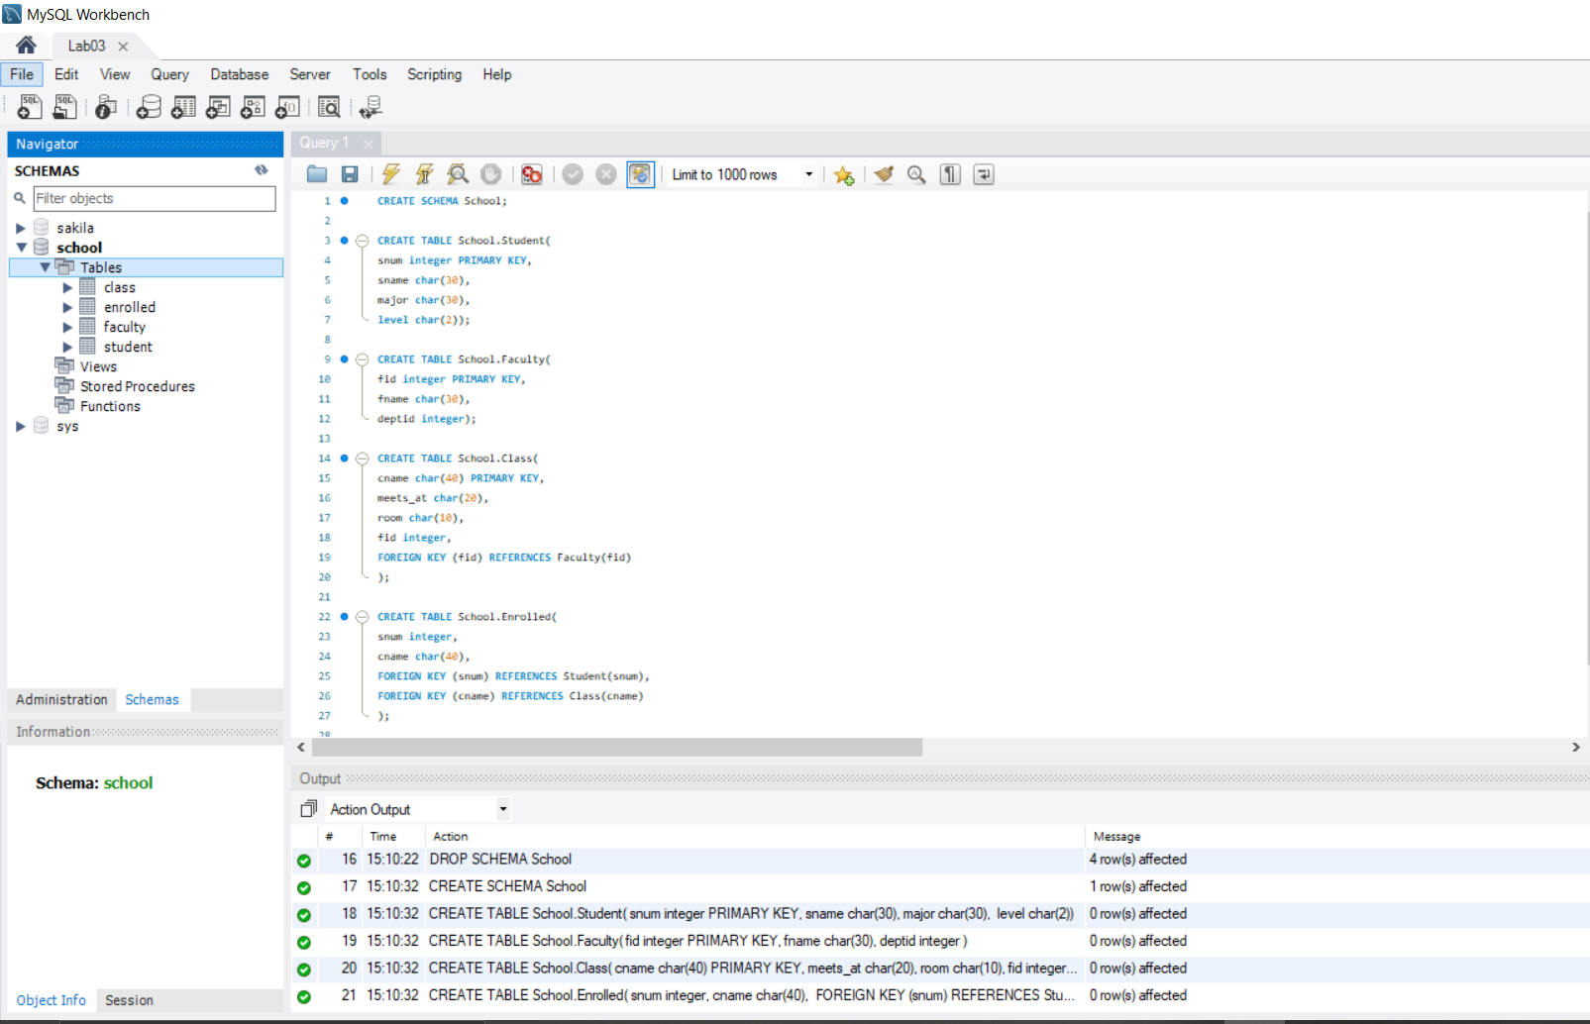

## Add a new attribute age in STUDENT table. ~~.~~

### Query:

ALTER TABLE School.Student

ADD age integer;

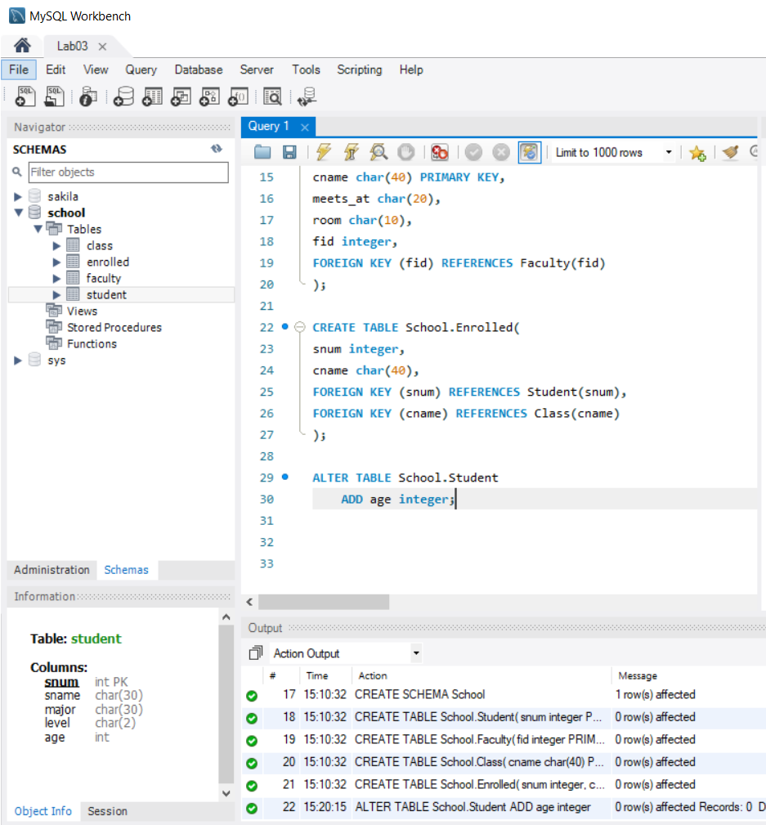

## Modify data type of attribute: NAME (i.e. cname, sname, fname) in all tables to varchar data type.

### Query:

ALTER TABLE School.Student

MODIFY sname varchar(30);

ALTER TABLE School.Faculty

MODIFY fname varchar(30);

ALTER TABLE School.Class

MODIFY room varchar(40) ;

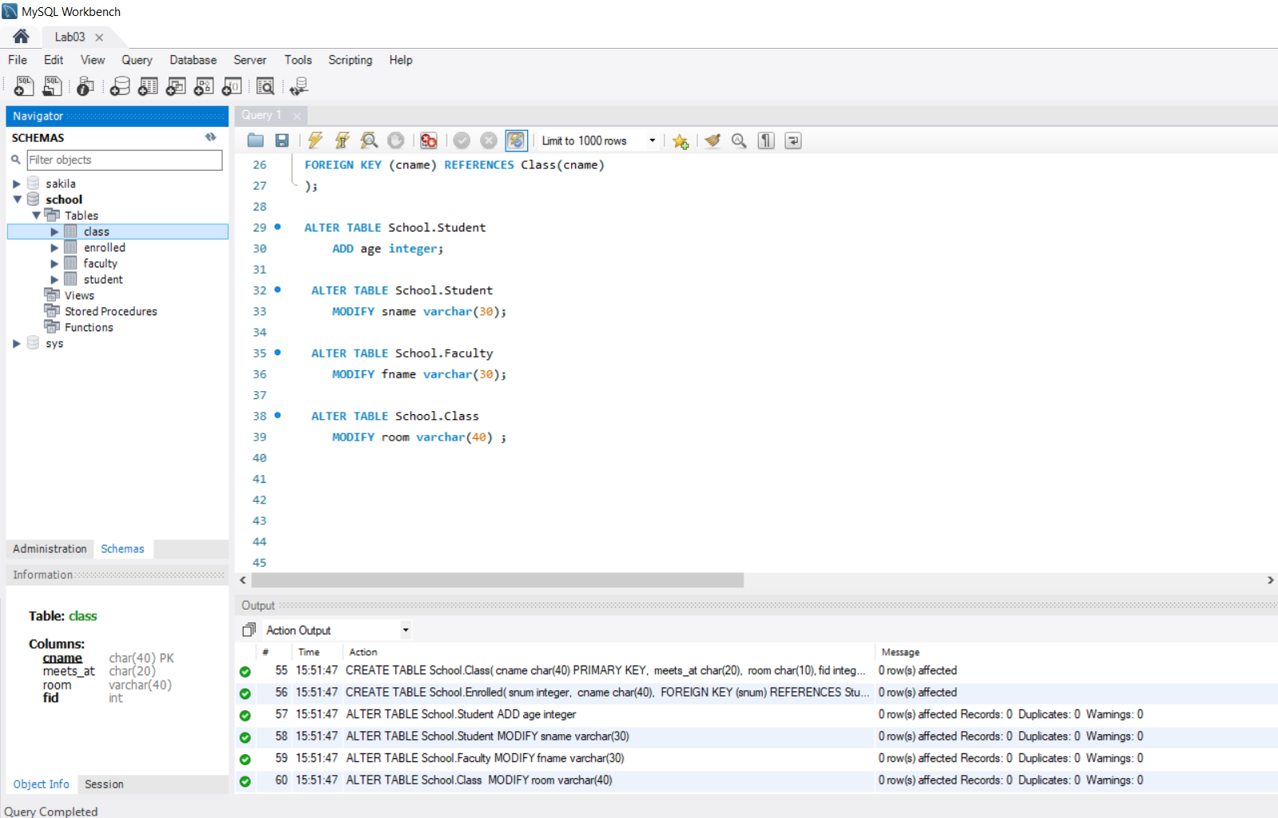

## Add a new NOT NULL constraint to DEPTID in FACULTY table.

### Query:

ALTER TABLE School.Faculty

MODIFY deptid integer NOT NULL;

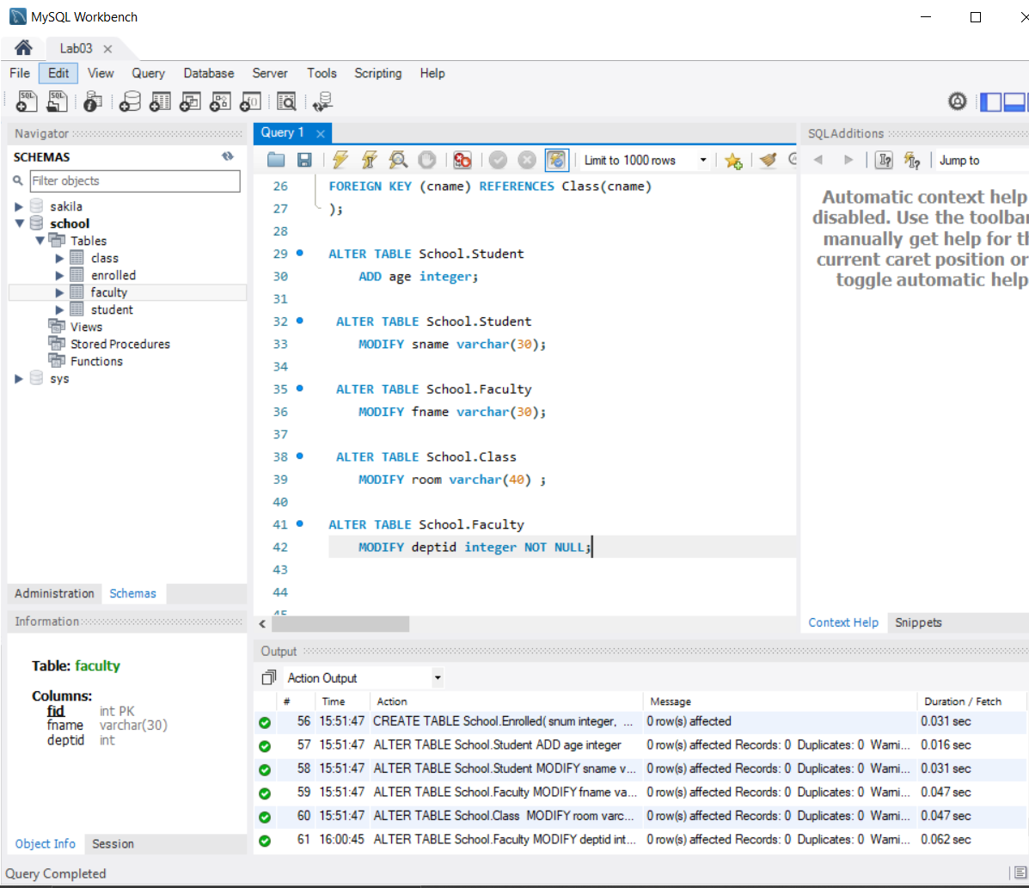

## After creating the database using your SQL statements, populate the database according to the data given in text files using the SQL INSERT commands.

### Query:

INSERT INTO School.Student values

(

1, 'Ahmed', 'science', 'S', 20

);

INSERT INTO School.Faculty values

(

2, 'Ali', 2

);

INSERT INTO School.Class values

(

'physics', 'morning', 'lab', 2

);

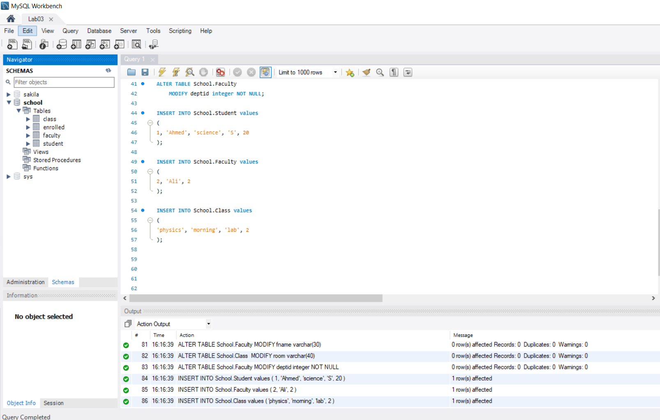

## The tables after all the modification are:

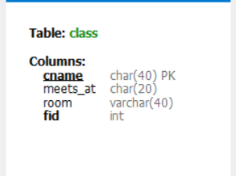 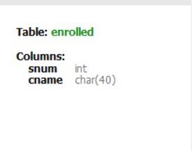

 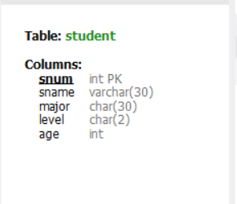

## The tables with values entered are:

### Query:

SELECT * FROM School.Student;

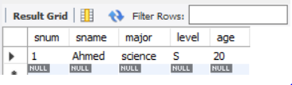

### Query:

SELECT * FROM School.Faculty;



### Query:

SELECT * FROM School.Class;

